**WORKSHOP**

**“ELECTRIC CIRCUITS & SYMBOLS” NICOLAS MARTINEZ 2450699**

1. LEA LA SIGUIENTE INFORMACION ACERCA DE LOS SIMBOLOS ELECTRICOS. BUSQUE LAS PALABRAS DESCONOCIDAS.

**Table of Electrical Symbols**

|  |  |  |
| --- | --- | --- |
| Symbo l | Component name | Meaning |
| Wire Symbols | | |
|  | [Electrical Wire](https://en.wikipedia.org/wiki/Electrical_wiring) | Conductor of electrical current |
|  | [Connected Wires](https://en.wikipedia.org/wiki/Electrical_wiring) | Connected crossing |
|  | [Not Connected Wires](https://en.wikipedia.org/wiki/Electrical_wiring) | Wires are not connected |
| Switch Symbols and Relay Symbols | | |
|  | [SPST Toggle Switch](https://en.wikipedia.org/wiki/Switch) | Disconnects current when open |
|  | [SPDT Toggle Switch](https://en.wikipedia.org/wiki/Switch) | Selects between two connections |
|  | Pushbutton Switch (N.O) | Momentary switch - normally open |
|  | Pushbutton Switch (N.C) | Momentary switch - normally closed |
|  | [DIP Switch](https://www.rapidtables.com/electric/DIP_Switch.html) | DIP switch is used for onboard configuration |
|  | [SPST Relay](https://en.wikipedia.org/wiki/Relay) | Relay open / close connection by an electromagnet |
|  | [SPDT Relay](https://en.wikipedia.org/wiki/Relay) |

|  |  |  |
| --- | --- | --- |
|  |  |  |
|  | [Jumper](https://en.wikipedia.org/wiki/Jumper_(computing)) | Close connection by jumper insertion on pins. |
|  | [Solder Bridge](https://www.rapidtables.com/electric/solder-bridge.html) | Solder to close connection |
| Ground Symbols | | |
|  | [Earth Ground](https://en.wikipedia.org/wiki/Ground_(electricity)) | Used for zero potential reference and electrical shock protection. |
|  | [Chassis Ground](https://en.wikipedia.org/wiki/Ground_(electricity)) | Connected to the chassis of the circuit |
|  | [Digital / Common Ground](https://en.wikipedia.org/wiki/Ground_(electricity)) |  |
| Resistor Symbols | | |
|  | [Resistor](https://www.rapidtables.com/electric/resistor.html) (IEEE) | Resistor reduces the current flow. |
|  | [Resistor](https://www.rapidtables.com/electric/resistor.html) (IEC) |
|  | [Potentiometer](https://en.wikipedia.org/wiki/Potentiometer) (IEEE) | Adjustable resistor - has 3 terminals. |
|  | [Potentiometer](https://en.wikipedia.org/wiki/Potentiometer) (IEC) |
|  | [Variable Resistor /](https://en.wikipedia.org/wiki/Potentiometer)  [Rheostat](https://en.wikipedia.org/wiki/Potentiometer) (IEEE) | Adjustable resistor - has 2 terminals. |
|  | [Variable Resistor /](https://en.wikipedia.org/wiki/Potentiometer)  [Rheostat](https://en.wikipedia.org/wiki/Potentiometer) (IEC) |
|  | Trimmer Resistor | Preset resistor |
|  | Thermistor | Thermal resistor - change resistance when temperature changes |

|  |  |  |
| --- | --- | --- |
|  |  |  |
|  | Photoresistor / Light dependent resistor (LDR) | Photo-resistor - change resistance with light intensity change |
| Capacitor Symbols | | |
|  | [Capacitor](https://www.rapidtables.com/electric/capacitor.html) | Capacitor is used to store electric charge. It acts as short circuit with AC and open circuit with DC. |
|  | [Capacitor](https://www.rapidtables.com/electric/capacitor.html) |
|  | [Polarized Capacitor](https://en.wikipedia.org/wiki/Capacitor) | [Electrolytic capacitor](https://en.wikipedia.org/wiki/Electrolytic_capacitor) |
|  | [Polarized Capacitor](https://en.wikipedia.org/wiki/Capacitor) | [Electrolytic capacitor](https://en.wikipedia.org/wiki/Electrolytic_capacitor) |
|  | [Variable Capacitor](https://en.wikipedia.org/wiki/Variable_capacitor) | Adjustable capacitance |
| Inductor / Coil Symbols | | |
|  | [Inductor](https://www.rapidtables.com/electric/inductor.html) | Coil / solenoid that generates magnetic field |
|  | [Iron Core Inductor](https://www.rapidtables.com/electric/inductor.html) | Includes iron |
|  | [Variable Inductor](https://www.rapidtables.com/electric/inductor.html) |  |
| Power Supply Symbols | | |
|  | [Voltage Source](https://en.wikipedia.org/wiki/Voltage_source) | Generates constant voltage |
|  | [Current Source](https://en.wikipedia.org/wiki/Current_source) | Generates constant current. |
|  | AC Voltage Source | AC voltage source |

|  |  |  |
| --- | --- | --- |
|  | [Generator](https://en.wikipedia.org/wiki/Electrical_generator) | Electrical voltage is generated by mechanical rotation of the generator |
|  | [Battery Cell](https://en.wikipedia.org/wiki/Battery_(electricity)) | Generates constant voltage |
|  | [Battery](https://en.wikipedia.org/wiki/Battery_(electricity)) | Generates constant voltage |
|  | [Controlled Voltage Source](https://en.wikipedia.org/wiki/Voltage_source) | Generates voltage as a function of voltage or current of other circuit element. |
|  | [Controlled Current Source](https://en.wikipedia.org/wiki/Current_source) | Generates current as a function of voltage or current of other circuit element. |
| Meter Symbols | | |
|  | [Voltmeter](https://en.wikipedia.org/wiki/Voltmeter) | Measures voltage. Has very high resistance. Connected in parallel. |
|  | [Ammeter](https://en.wikipedia.org/wiki/Ammeter) | Measures electric current. Has near zero resistance. Connected serially. |
|  | [Ohmmeter](https://en.wikipedia.org/wiki/Ohmmeter) | Measures resistance |
|  | [Wattmeter](https://en.wikipedia.org/wiki/Wattmeter) | Measures electric power |
| Lamp / Light Bulb Symbols | | |
|  | [Lamp](https://en.wikipedia.org/wiki/Lamp_(electrical_component)) / light bulb | Generates light when current flows through |
|  | Lamp / light bulb |
|  | Lamp / light bulb |
| Diode / LED Symbols | | |
|  | [Diode](https://en.wikipedia.org/wiki/Diode) | Diode allows current flow in one direction only - |

|  |  |  |
| --- | --- | --- |
|  |  | left (anode) to right (cathode). |
|  | [Zener Diode](https://en.wikipedia.org/wiki/Zener_diode) | Allows current flow in one direction, but also can flow in the reverse direction when above breakdown voltage |
|  | [Schottky Diode](https://en.wikipedia.org/wiki/Schottky_diode) | Schottky diode is a diode with low voltage drop |
|  | [Varactor / Varicap Diode](https://en.wikipedia.org/wiki/Varicap) | Variable capacitance diode |
|  | [Tunnel Diode](https://en.wikipedia.org/wiki/Tunnel_diode) |  |
|  | [Light Emitting Diode (LED)](https://en.wikipedia.org/wiki/LED) | LED emits light when current flows through |
|  | [Photodiode](https://en.wikipedia.org/wiki/Photodiode) | Photodiode allows current flow when exposed to light |
| Transistor Symbols | | |
|  | [NPN Bipolar Transistor](https://en.wikipedia.org/wiki/Bipolar_junction_transistor) | Allows current flow when high potential at base  (middle) |
|  | [PNP Bipolar Transistor](https://en.wikipedia.org/wiki/Bipolar_junction_transistor) | Allows current flow when low potential at base  (middle) |
|  | [Darlington Transistor](https://en.wikipedia.org/wiki/Darlington_transistor) | Made from 2 bipolar transistors. Has total gain of the product of each gain. |
|  | [JFET-N Transistor](https://en.wikipedia.org/wiki/JFET) | N-channel field effect transistor |
|  | [JFET-P Transistor](https://en.wikipedia.org/wiki/JFET) | P-channel field effect transistor |
|  | [NMOS Transistor](https://en.wikipedia.org/wiki/MOSFET) | N-channel MOSFET transistor |
|  | [PMOS Transistor](https://en.wikipedia.org/wiki/MOSFET) | P-channel MOSFET transistor |

|  |  |  |
| --- | --- | --- |
|  |  |  |
| Misc. Symbols | | |
|  | [Motor](https://en.wikipedia.org/wiki/Electric_motor) | Electric motor |
|  | [Transformer](https://en.wikipedia.org/wiki/Transformer) | Change AC voltage from high to low or low to high. |
|  | Electric bell | Rings when activated |
|  | [Buzzer](https://en.wikipedia.org/wiki/Buzzer) | Produce buzzing sound |
|  | [Fuse](https://en.wikipedia.org/wiki/Fuse_(electrical)) | The fuse disconnects when current above threshold. Used to protect circuit from high currents. |
|  | [Fuse](https://en.wikipedia.org/wiki/Fuse_(electrical)) |
|  | [Bus](https://en.wikipedia.org/wiki/Electrical_bus) | Contains several wires. Usually for data / address. |
|  | [Bus](https://en.wikipedia.org/wiki/Electrical_bus) |
|  | [Bus](https://en.wikipedia.org/wiki/Electrical_bus) |
|  | [Optocoupler / Opto-isolator](https://en.wikipedia.org/wiki/Optocoupler) | Optocoupler isolates connection to other board |
|  | [Loudspeaker](https://en.wikipedia.org/wiki/Loudspeaker) | Converts electrical signal to sound waves |
|  | [Microphone](https://en.wikipedia.org/wiki/Microphone) | Converts sound waves to electrical signal |
|  | [Operational Amplifier](https://en.wikipedia.org/wiki/Operational_amplifier) | Amplify input signal |

|  |  |  |
| --- | --- | --- |
|  |  |  |
|  | [Schmitt Trigger](https://en.wikipedia.org/wiki/Schmitt_trigger) | Operates with hysteresis to reduce noise. |
|  | [Analog-to-digital converter](https://en.wikipedia.org/wiki/Analog-to-digital_converter)  [(ADC)](https://en.wikipedia.org/wiki/Analog-to-digital_converter) | Converts analog signal to digital numbers |
|  | [Digital-to-Analog converter](https://en.wikipedia.org/wiki/Digital-to-analog_converter)  [(DAC)](https://en.wikipedia.org/wiki/Digital-to-analog_converter) | Converts digital numbers to analog signal |
|  | [Crystal Oscillator](https://en.wikipedia.org/wiki/Crystal_oscillator) | Used to generate precise frequency clock signal |
| ⎓ | Direct current | Direct current is generated from constant voltage level |
| Antenna Symbols | | |
|  | [Antenna / aerial](https://en.wikipedia.org/wiki/Antenna_(radio)) | Transmits & receives radio waves |
|  | [Antenna / aerial](https://en.wikipedia.org/wiki/Antenna_(radio)) |
|  | [Dipole Antenna](https://en.wikipedia.org/wiki/Dipole_antenna) | Two wires simple antenna |
| Logic Gates Symbols | | |
|  | [NOT Gate (Inverter](https://en.wikipedia.org/wiki/NOT_gate)) | Outputs 1 when input is 0 |
|  | [AND Gate](https://en.wikipedia.org/wiki/AND) | Outputs 1 when both inputs are 1. |
|  | [NAND Gate](https://en.wikipedia.org/wiki/NAND_logic) | Outputs 0 when both inputs are 1. (NOT +  AND) |
|  | [OR Gate](https://en.wikipedia.org/wiki/OR_gate) | Outputs 1 when any input is 1. |
|  | [NOR Gate](https://en.wikipedia.org/wiki/NOR_logic) | Outputs 0 when any input is 1. (NOT + OR) |
|  | [XOR Gate](https://en.wikipedia.org/wiki/XOR_gate) | Outputs 1 when inputs are different. (Exclusive  OR) |
|  | [D Flip-Flop](https://en.wikipedia.org/wiki/Flip-flop_(electronics)) | Stores one bit of data |
|  | [Multiplexer / Mux](https://en.wikipedia.org/wiki/Multiplexer) 2 to 1 | Connects the output to selected input line. |
|  | [Multiplexer / Mux](https://en.wikipedia.org/wiki/Multiplexer) 4 to 1 |
|  | [Demultiplexer / Demux](https://en.wikipedia.org/wiki/Multiplexer) 1 to  4 | Connects selected output to the input line. |

1. A CONTINUACION, OBSERVE LOS SIMBOLOS ELECTRICOS Y RELACIONE EL NOMBRE DEL COMPONENTE ELECTRICO EN INGLES CON EL SIMBOLO.
2. A CONTINUACION, OBSERVE LOS SIMBOLOS ELECTRICOS Y RELACIONE EL NOMBRE DEL COMPONENTE ELECTRICO EN INGLES CON EL SIMBOLO.



open switch

closed switch

lamp



resistor

ammeter

voltmeter

LDR

battery

Battery cell



variable resistor

thermistor

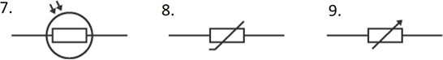

fuse

1. DISEÑE CON LAS IMÁGENES UN CIRCUITO ELECTRICO SIMPLE.

|  |  |
| --- | --- |
|  |  |

3. DISEÑE CON LAS IMÁGENES UN CIRCUITO ELECTRICO SIMPLE.

ADICIONALMENTE A ESTO, CREE EL CIRCUITO ELECTRICO CON LOS

SIMBOLOS ELECTRICOS.

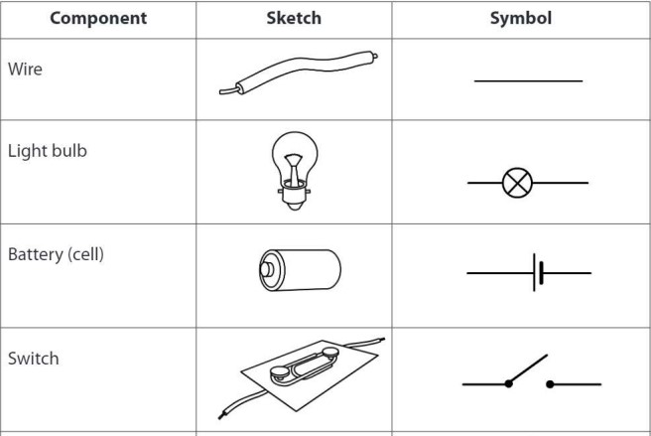

GRAPHICS HERE:

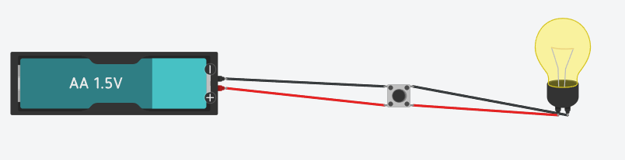 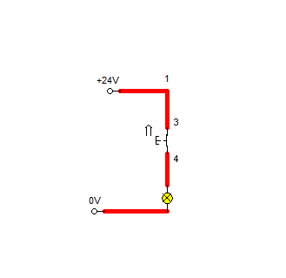

1. INVESTIGUE CUALES SON LAS HERRAMIENTOS DE MEDICION

# ELECTRICA (ELECTRIC MEASURE TOOLS) MAS IMPORTANTES. NOMBRE

4 CON SUS RESPECTIVOS NOMBRES EN INGLES Y DIGA CUAL ES SU UNIDAD DE MEDIDA. COLOQUE LAS IMÁGENES DE CADA HERRAMIENTA DE MEDICION ELECTRICA.

|  |  |  |
| --- | --- | --- |
| **NAME OF THE TOOL** | **IMAGE OF THE TOOL** | **UNIT OF MEASUREMENT** |
| 1. VOLTMETER | Voltímetro 【 Qué es y Cómo funciona un voltímetro 】 | Volt (V) |
| 2. AMMETER | Amperímetro - Medir resistencia | De Máquinas y Herramientas | Volt Amper (VA) |
| 3.MULTIMETER | ➤▷ ¿Que es un MULTIMETRO? | Todo lo que Necesitas Saber 🥇 | Faradio (F) |
| 4.FRECUENCY METER | Frecuencimetro Herramientas Testers Y Equipos Medicion | MercadoLibre 📦 | Hertz (Hz) |

5. INVESTIGUE CUALES SON LOS ELEMENTOS DE PROTECCION PERSONAL EN INGLES Y NOMBRE DOS (2) COMPONENTES DE PROTECCION EN UN CIRCUITO ELECTRICO. COLOQUE IMÁGENES CON SUS RESPECTIVOS NOMBRES.

**ELECTRIC PERSONAL PROTECTIVE EQUIPMENT – EPPE.**

DIALECTICAL BOOTS:

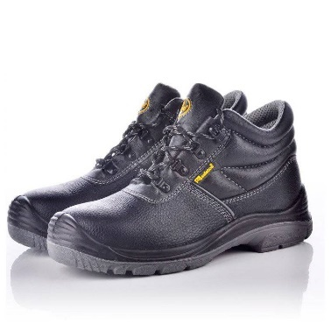

SAFETY HELMET:

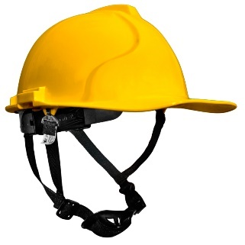

**ELECTRIC PROTECTIVE COMPONENT – EPC.**

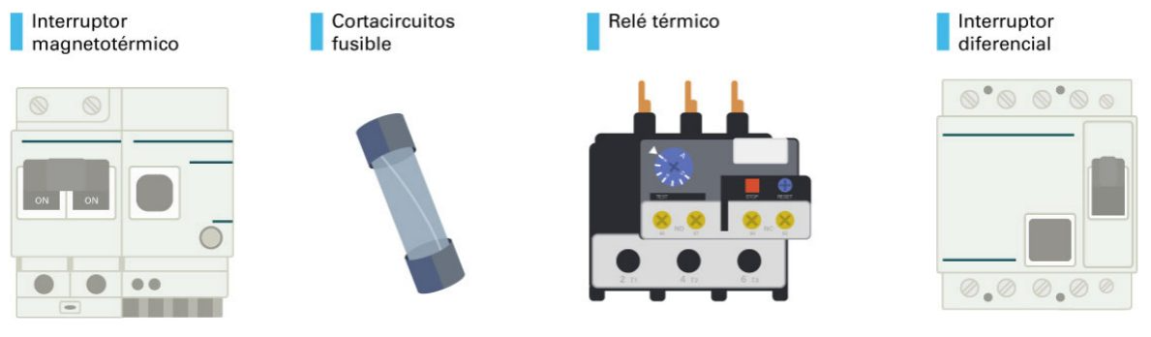

Diferencial Switch

Thermal Relay

Circuit Breaker Fuse

Circuit Breaker